**Evaluation fin SQL: Sandy**

**Partie 1: MCD/MLD**

MCD

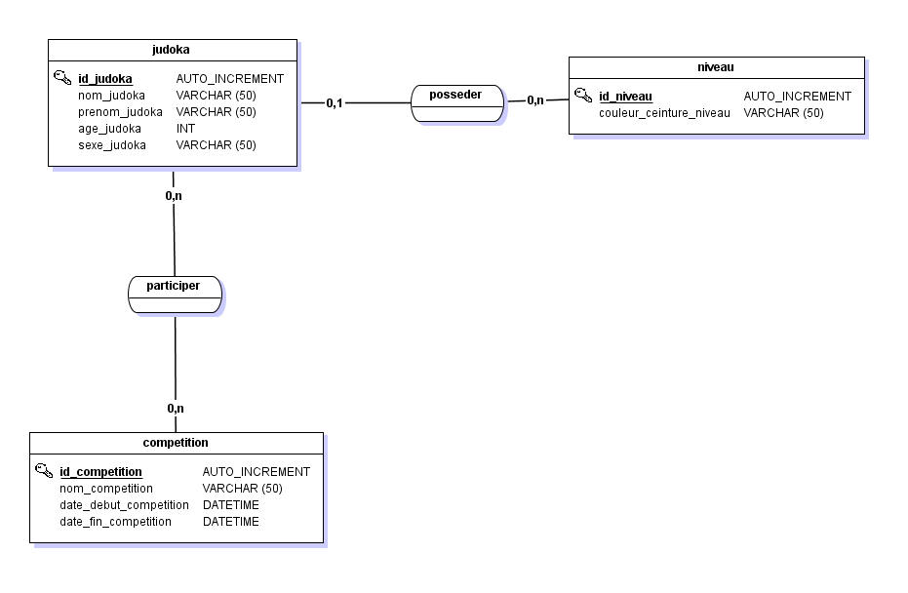MLD

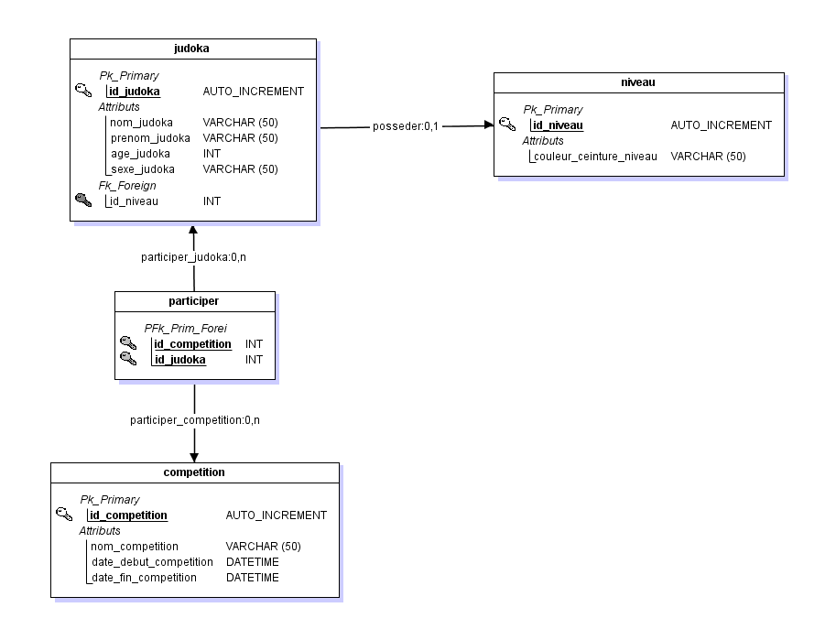

**Partie 2: Création de la structure de base de données:**

create database evaljudoka;

use evaljudoka;

create table niveau(

id_niveau int primary key auto_increment not null,

couleur_ceinture_niveau varchar(50)

)Engine = InnoDB;

create table judoka(

id_judoka int primary key auto_increment not null,

nom_judoka varchar(50) not null,

prenom_judoka varchar(50) not null,

age_judoka int not null,

sexe_judoka varchar(50),

id_niveau int not null

)Engine = InnoDB;

create table competition(

id_competition int primary key auto_increment not null,

nom_competition varchar(50) not null,

date_debut_competition datetime not null,

date_fin_competition datetime not null

)Engine = InnoDB;

create table participer(

id_competition int not null,

id_judoka int not null,

primary key(id_competition,id_judoka)

)Engine = InnoDB;

-- contraintes:

alter table judoka

add constraint fk_posseder_niveau

foreign key(id_niveau)

references niveau(id_niveau);

alter table participer

add constraint fk_participer_judoka

foreign key(id_judoka)

references judoka(id_judoka);

alter table participer

add constraint fk_participer_competition

foreign key(id_competition)

references competition(id_competition);

-- les inserts:

insert into niveau(couleur_ceinture_niveau) values

('blanche'),('jaune'),('orange'),('verte'),('bleu'),('marron'),('noire');

insert into judoka (nom_judoka, prenom_judoka, age_judoka, sexe_judoka, id_niveau) values

('lachance','dominique',16,'F',2),

('porter','gilbert',18,'H',3),

('lemaître','anne',15,'F',4),

('robert','juliette',12,'F',1),

('montminy','pierre',17,'H',1),

('charrette','pascal',21,'H',6),

('guay','emilie',19,'F',6),

('maheu','louise',14,'F',4),

('Poulin','Raymond',26,'H',7),

('Dupret','Alain',20,'H',6);

insert into competition(nom_competition, date_debut_competition, date_fin_competition) values

('judo31','2021-02-06','2021-02-07'),

('judo31','2021-02-06','2021-02-07'),

('Judo81','2021-03-20','2021-03-21'),

('Judo82','2021-04-17','2021-04-18');

insert into participer(id_competition,id_judoka) values

(1,1),(1,3),(1,4),(2,2),(2,5),

(2,6),(2,9),(3,10),(3,9),(4,1),

(4,3),(4,8),(4,4);

-- les updates:

update judoka set id_niveau=(id_niveau+1) where id_judoka<6;

-- insert et suppression:

insert into judoka (nom_judoka, prenom_judoka, age_judoka, sexe_judoka, id_niveau) values

('lachance','henri',18,'H',6),

('sartres','laurie',16,'F',6);

-- les delete:

delete from judoka where id_judoka = 11;

delete from judoka where id_judoka = 12;

-- les requêtes select

select nom_judoka,prenom_judoka from judoka where id_niveau=4;

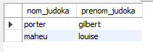

select count(id_judoka) from participer inner join competition where nom_competition= 'judo31';

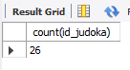

select nom_judoka, prenom_judoka, age_judoka,sexe_judoka from judoka inner join competition where nom_competition ='judo81';

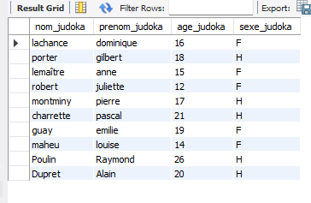

select nom_judoka,prenom_judoka, age_judoka from judoka inner join niveau where judoka.id_niveau=6 and age_judoka<19;

-- réponse il n’y en a pas j’ai essayé avec d’autres niveau et j’ai eu des résultats

select nom_judoka,prenom_judoka,couleur_ceinture_niveau from judoka inner join niveau

order by nom_judoka asc;

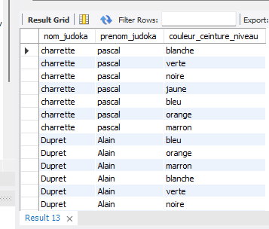

Et voilà, bon courage pour la correction et bon week-end!